**NENO SACCO ONLINE BOOKING SYSTEM**

**BY**

**VICTOR KARANJA NJUGUNA**

**SCT121-0825/2022**

**SYSTEM ANALYSIS AND DESIGN REPORY**

**SUBMITTED TO THE DEPARTMENT OF INFORMANTION**

**TECHNOLOGY IN THE SCHOOL OF COMPUTING AND INFORMATION**

**TECHNOLOGY IN JOMO KENYATTA UNIVERSITY OF AGRICULTURE AND**

**TECHNOLOGY**

**JULY 2024**

**DECLARATION**

I hereby declare that this is my own original work that is first presented by me, and has not been submitted to any other University or Institute or published earlier by any other students.

**Abstract**

This document details the system analysis and design for transforming Neno Sacco's manual booking process into an efficient digital platform. It includes a feasibility study covering technical, economic, and operational aspects, and requirements elicitation and analysis to gather functional and non-functional requirements. The system design phase outlines logical and physical designs, including use case, activity, class, and sequence diagrams. System architecture is discussed, highlighting client-side and server-side components along with database design. The physical design covers database structure and entity-relationship diagrams. Finally, interface design includes login, registration, and booking pages for a seamless user experience.

**Table of Contents**

**3.1 FEASIBILITY STUDY** 4

**3.1.1 TECHNICAL FEASIBILITY** 4

**3.1.2 ECONOMIC FEASIBILITY** 6

**3.1.3 OPERATIONAL FEASIBILITY** 9

**3.2. REQUIREMENTS ELICITATION AND ANALYSIS** 11

**3.2.1 Requirements Elicitation** 11

**3.3 REQUIREMENTS ANALYSIS** 13

**3.3.1Functional Requirements** 13

**3.3.2 NON-FUNCTIONAL REQUIREMENTS** 14

**3.4 SYSTEM DESIGN** 16

**3.4.1 LOGICAL DESIGN** 16

**3.4.1.1. Use case Diagram** 16

**3.4.1.2.Activity diagram** 17

**3.4.1.3 CLASS DIAGRAM** 19

**3.4.1.5. SEQUENCE DIAGRAM** 20

**3.4.1.6 System Architecture** 21

**3.5 PHYSICAL DESIGN** 24

**3.5.1 Database Design** 24

**3.5.2 Interface Design** 26

# **CHAPTER THREE**

# **SYSTEM ANALYSIS AND DESIGN**

## **INTRODUCTION**

This chapter outlines the transformation of the manual booking process into a digital platform for Neno Sacco. Key tasks include a feasibility study to assess technical, economic, and operational aspects, requirements elicitation and analysis, logical and physical system design, database design for efficient data management, and user interface design for intuitive interaction. These steps ensure a comprehensive system analysis and design, paving the way for successful implementation.

## **3.1 FEASIBILITY STUDY**

## **3.1.1 TECHNICAL FEASIBILITY**

**1. Overview**

The technical feasibility analysis evaluates whether the proposed Neno Sacco Online Booking System can be developed and implemented using the available technology and resources. This includes an assessment of the system's technological requirements, the expertise needed, and the compatibility with existing infrastructure.

**2. Technological Requirements**

* **Hardware Requirements**:
  + **Servers**: Adequate server infrastructure to host the application, database, and handle web traffic.
  + **Network Infrastructure**: Reliable internet connectivity and network equipment to support seamless user access and data transmission.
  + **User Devices**: Compatibility with various devices (desktops, laptops, tablets, smartphones) used by passengers and Neno Sacco staff.
* **Software Requirements**:
  + **Operating System**: Server operating systems (e.g., Linux,Android, Windows Server) to run the application.
  + **Web Server Software**: Apache, Nginx, or similar to serve the web application.
  + **Database Management System**: MySQL.
  + **Programming Languages**: Languages such as HTML, CSS, PHP, or JavaScript for developing the application.
  + **Frameworks and Libraries**: Use of web development frameworks (e.g.,Laravel) enhance the efficiency, quality, and maintainability of the Neno Sacco Online Booking System.
  + **Security Software**: SSL/TLS certificates, firewalls, and other security measures to protect user data.

## **3.1.2 ECONOMIC FEASIBILITY**

**1. Introduction**

This economic feasibility study evaluates the cost-effectiveness of developing and implementing the Neno Sacco Online Booking System. It examines the financial aspects, including initial and ongoing costs, as well as the anticipated benefits, to determine if the project is economically viable.

**2. Cost Considerations**

**2.1 Initial Development Costs**

* **Hardware**:
  + Servers
  + Networking equipment: Ksh4500
  + User devices: Available
* **Software**:
  + Server OS licenses: Available
  + Database Management System: Free
  + Web server software: Free
  + Development tools and IDEs: Free
* **Personnel**:
  + Developers: Available
  + UI/UX Designers: Available
  + Project Managers: Available
  + System Administrators: Available.

**Total Initial Development Costs**: Ksh4500

**2.2 Ongoing Operational Costs**

* **Hosting and Maintenance**:
  + Server hosting (annual):Ksh10,000
  + Maintenance and support (annual):Ksh6000
* **Personnel**:
  + Ongoing support and maintenance staff (annual): Ksh15,000

**Total Annual Operational Costs**: Ksh31,000.

**3. Benefit Analysis**

**3.1 Direct Benefits**

* **Revenue Increase**:
  + Increased bookings due to convenience: Projected 3.5% increase in bookings
  + Current annual revenue from bookings: Ksh150000
  + Projected annual revenue increase: Ksh15000
* **Cost Savings**:
  + Reduced staffing needs for manual booking: Ksh35000 annually
  + Reduced paper and printing costs:Ksh7000 annually

**3.2 Indirect Benefits**

* **Enhanced Customer Satisfaction**:
  + Improved user experience leading to higher customer retention
  + Positive word-of-mouth and increased brand loyalty
* **Operational Efficiency**:
  + Streamlined booking process reducing operational bottlenecks
  + Better management of seat availability and scheduling

**4. Cost-Benefit Analysis**

**4.1 Initial Investment Recoup Period**

* Total initial development costs: Ksh38500
* Annual net benefit (revenue increase + cost savings - operational costs): Ksh220,000

**4.2 Return on Investment (ROI)**

* Annual net benefit:Ksh220000
* ROI = (42000\220000) * 100 ≈ 19.1%

**5. Conclusion**

The economic feasibility study indicates that the Neno Sacco Online Booking System is a viable investment. The project promises a 14% return on investment, along with significant indirect benefits such as enhanced customer satisfaction and operational efficiency. These factors collectively justify the financial commitment to the project, suggesting that it is economically feasible and strategically advantageous for Neno Sacco.

## **3.1.3 OPERATIONAL FEASIBILITY**

**1. Introduction**

This operational feasibility study report analyzes the operational feasibility of the proposed Neno Sacco Online Booking System. The report examines the project's alignment with Neno Sacco's existing operations, resource requirements, and potential impact on organizational processes.

**2. Alignment with Existing Operations**

The Neno Sacco Online Booking System aligns with Neno Sacco's existing operations by:

* **Streamlining the booking process:** The online system will automate the booking process, reducing manual tasks and improving efficiency.
* **Improving customer experience:** The online system will provide passengers with a convenient and user-friendly way to book their travel arrangements.
* **Real-time seat availability:** The online system will provide real-time seat availability information, eliminating confusion and frustration for passengers.
* **Integration with existing systems:** The online system can be integrated with Neno Sacco's existing ticketing and accounting systems, providing a seamless experience for both passengers and staff.

**3. Resource Requirements**

The Neno Sacco Online Booking System will require the following resources:

* **Human resources:** Skilled personnel will be required for system development, maintenance, and customer support.
* **Technical resources:** Hardware, software, and network infrastructure will be required to host and operate the online system.
* **Financial resources:** Funding will be required for development, implementation, and ongoing operational costs.

**4. Impact on Organizational Processes**

The Neno Sacco Online Booking System will impact organizational processes by:

* **Changing the booking process:** The manual booking process will be replaced with an online system, requiring staff to adapt to new procedures.
* **Improving data management:** The online system will require accurate and up-to-date data management to ensure real-time seat availability and efficient operations.
* **Enhancing customer service:** The online system will require customer service staff to be familiar with the system and assist passengers with any issues they may encounter.

**6. Conclusion**

The Neno Sacco Online Booking System is operationally feasible. The system aligns with Neno Sacco's existing operations, can be implemented with the available resources, and will have a positive impact on organizational processes.

# **3.2. REQUIREMENTS ELICITATION AND ANALYSIS**

## **3.2.1 Requirements Elicitation**

Elicitation Techniques

Following techniques were used to gather requirements:

* Interviews
* Observations

**2.2 Stakeholder Interviews**

**Interviewees**

* Potential users (customers)
* Staff (Drivers)
* Management

**Key Questions**

1. What are the main problems with the current booking process?
2. What features would you like to see in the online booking system?
3. How should the payment process be handled?
4. What reports and analytics are needed for admin staff?

**Summary of Responses**

* Customers want an easy-to-use interface for booking and payment.
* Admins need a dashboard to manage bookings and view reports.
* Both users and admins emphasized the need for secure and reliable payment processing.

|  |  |  |
| --- | --- | --- |
| **Role** | **Number of respondents** | **Percentage %** |
| **Potential Users(Travellers)** | 2 | 25% |
| **Management** | 1 | 20% |
| **Staff(Drivers)** | 5 | 65% |

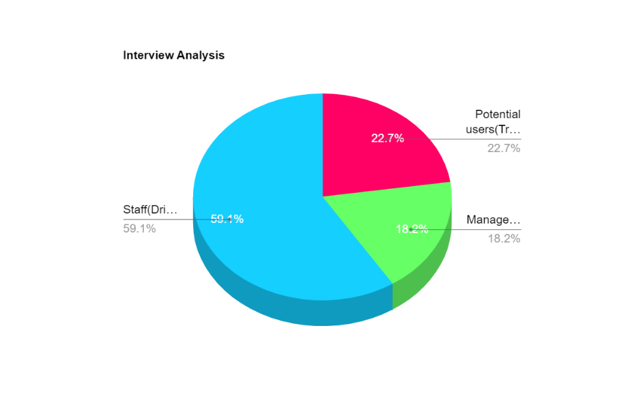

**Observations**

**Activities Observed**

* Current booking process at Neno Sacco offices.
* Interaction with existing systems (if any).

**Key Observations and Insights**

* The manual booking process is time-consuming and prone to errors.
* There is a lack of centralized data management.

# **3.3 REQUIREMENTS ANALYSIS**

## **3.3.1Functional Requirements**

* FR1: User Registration and Authentication
  + FR1.1: Allow users to register with a unique email, password and phone number.
  + FR1.2: Provide a login mechanism.
  + FR1.3: Allow users to reset their passwords.
* FR2: Booking Management
  + FR2.1: Display available routes and schedules.
  + FR2.2: Allow users to book seats on a selected route and schedule.
* FR3: Payment Processing
  + FR3.1: Integrate with a payment gateway for processing payments, Daraja API.
  + FR3.2: Generate and display payment receipts.
* FR5: Reporting and Analytics
  + FR5.1: Generate reports on bookings, payments, and user activities.
  + FR5.2: Provide analytics on system usage and performance.

## **3.3.2 NON-FUNCTIONAL REQUIREMENTS**

1. **Performance:**

The system should be responsive and handle high traffic volumes efficiently.

Page loading times should be minimal to ensure a smooth user experience.

1. **Security:**

The system should implement robust security measures to protect user data and prevent unauthorized access.

Secure data encryption and user authentication protocols should be in place.

1. **Reliability:**

The system should be highly reliable and minimize downtime to ensure uninterrupted service availability.

Regular backups and disaster recovery plans should be implemented.

1. **Usability:**

The user interface should be intuitive and easy to navigate for users of all technical abilities.

Clear instructions and help features should be readily available.

1. **Accessibility:**

The system should be accessible to users with disabilities, complying with relevant accessibility standards.

1. **Scalability:**

The system should be designed to accommodate future growth and expansion of Neno Sacco's operations.

1. **Maintainability:**

The system should be well-documented and easy to maintain for future updates and modifications.

# **3.4 SYSTEM DESIGN**

This design will show the structure of final system and partially explain how components would be structured and how they would operate and interact.

## **3.4.1 LOGICAL DESIGN**

This is basically the logical representation of the system which captures the structure, behavior and functionality of the system. The following are the representations of the system

### **3.4.1.1. Use case Diagram**

Use-case diagram identifies interactions between the system and actors. The use cases and actor in use-case diagram describe what the system does and how the actors use it.

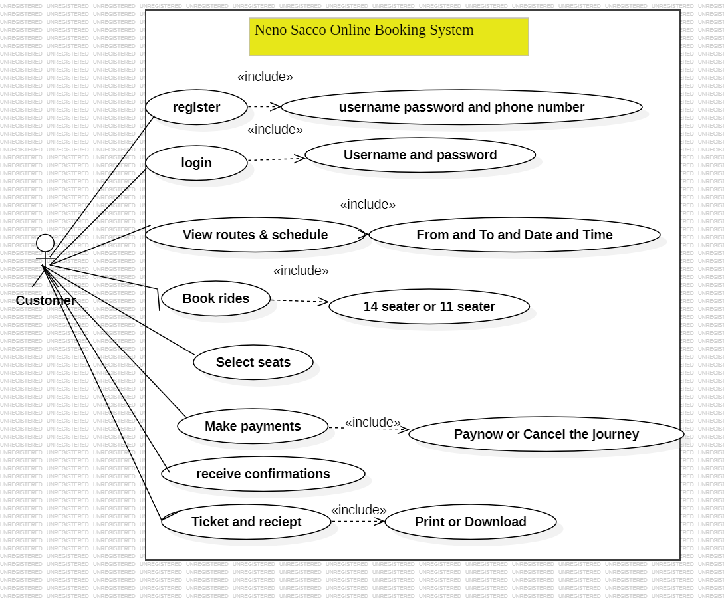

### **3.4.1.2.Activity diagram**

Activity diagram is a behavioural diagram that illustrated the flow of activities through a system. It was used to show the flow of events. It is used to identify the flow of the activities and requirements. The figure below showed an activity diagram for the Neno Sacco Online Booking System

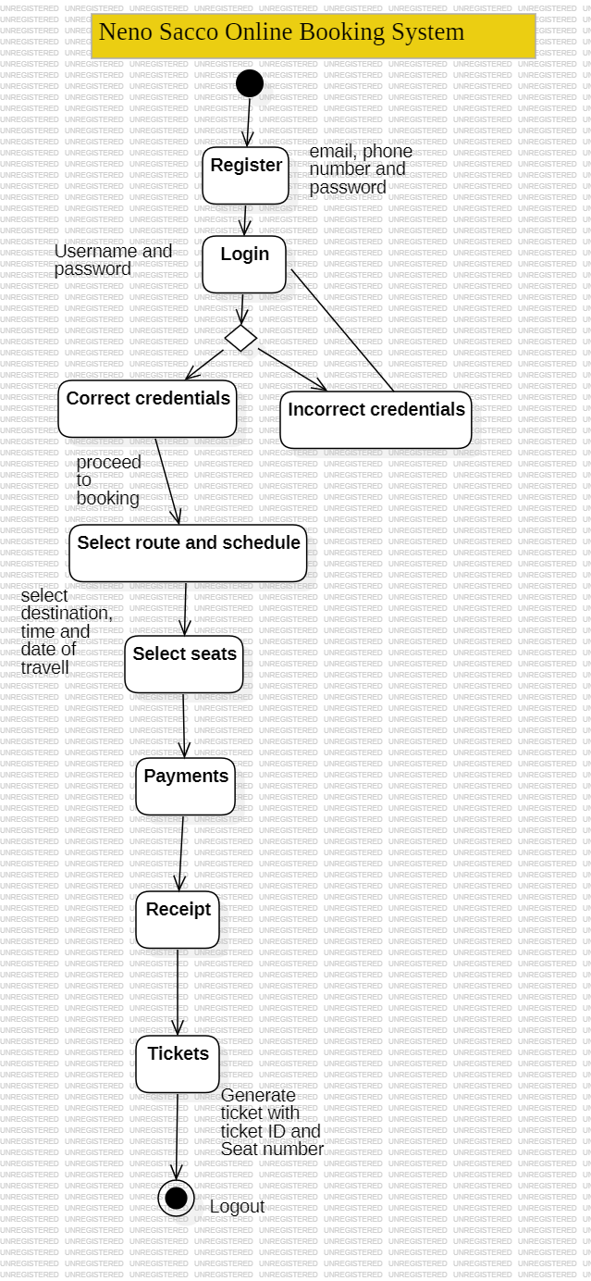

### **3.4.1.3 CLASS DIAGRAM**

Shows relationship between interacting objects displaying their attributes and operations.

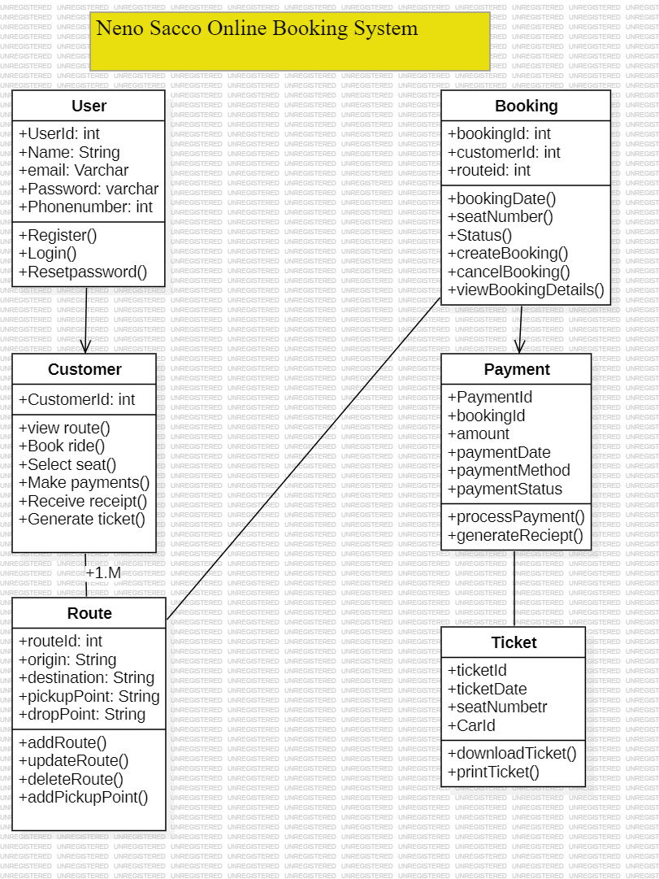

### **3.4.1.5. SEQUENCE DIAGRAM**

#### This showed how the objects were interacting with the system.

#### 

### **3.4.1.6 System Architecture**

***Client-Side (Frontend)***

The Web Application serves as the user interface for the Neno Sacco Online Booking System Users can log in, view available routes and schedules, select travel details, make bookings, and process payments.

***Server-Side (Backend)***

1. **Authentication**: It verifies user credentials during login and ensures that only authorized users can access specific functionalities of the system.
2. **Route**: It retrieves and validates route details that users can select during the booking process.
3. **Booking**: This service handles user bookings, ensuring the selected route, date, time, pickup station, drop-off station, and seat are accurately recorded and confirmed.
4. **Payment Service**: It interacts with the external payment gateway API (Daraja API) to process user payments securely and confirms successful transactions to the system.
5. **Notification Service**: Sends notifications such as booking confirmations and receipts to users.

***Database***

The Database stores all the necessary data for the system:

1. **User Database**: Contains user information, including login credentials and personal details. It ensures secure storage and retrieval of user data.
2. **Booking Database**: Stores detailed information about all bookings made by users. This includes travel details, payment status, and booking confirmations.
3. **Route Database**: Maintains information about available routes and schedules. It ensures that users can view accurate and up-to-date route options.
4. **Payment Database**: Records all payment transactions related to bookings. It tracks payment status and history for financial accountability.

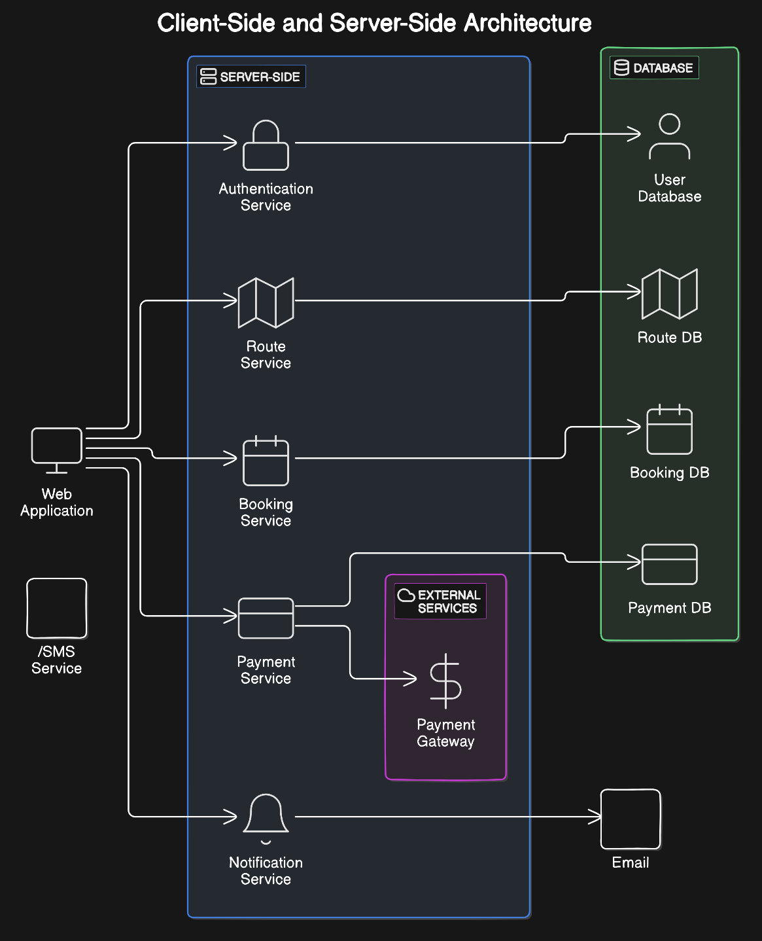

Fig: Neno Sacco Online Booking System, System Architecture.

## **3.5 PHYSICAL DESIGN**

Physical design of the system was considered as the physical environment which would support the logical flow of the system.

### **3.5.1 Database Design**

The database used was SQL Server which employed various storage mechanisms for storage and organization of data efficiently. Primary keys were used for unique identification

**b) ENTINTY-RELATIONSHIP DIAGRAM**

The Neno Sacco Online Booking System's database is designed to streamline user authentication, route management, booking processes, and payment handling. It includes four primary tables: Users (storing user credentials and personal details), Routes (detailing travel routes and schedules), Bookings (recording user bookings with travel specifics), and Payments (tracking financial transactions for each booking). This structure ensures data integrity, security, and efficient data management, supporting the system's goal of providing a seamless online booking experience.

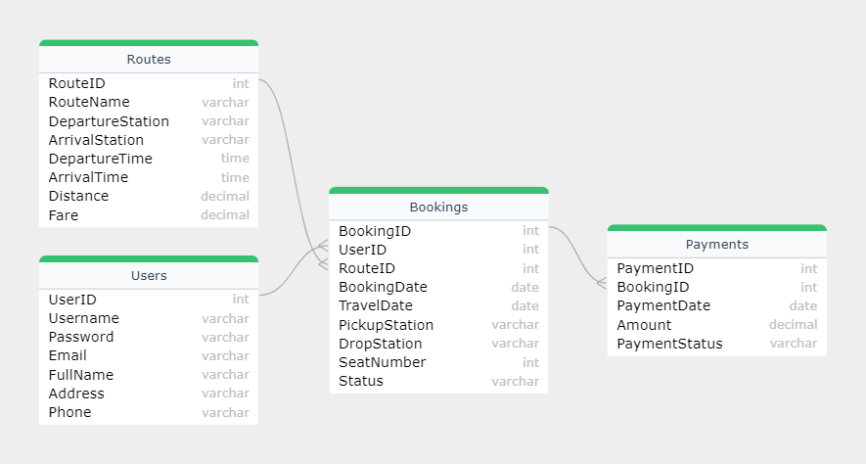

Fig: Entity Relationship Diagram

### **3.5.2 Interface Design**

#### 3.5.2.1Welcome page

The Welcome page, it includes the Neno sacco name. The user swipes to book.

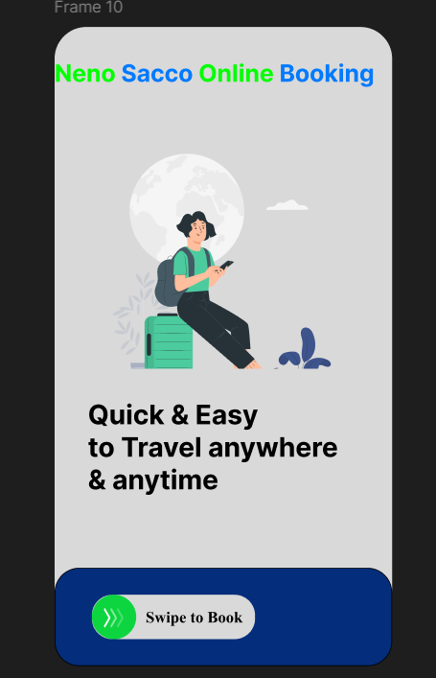

#### 3.5.2.2 Register Page

At this page, the user inputs email, phone number, password and confirms password to register.

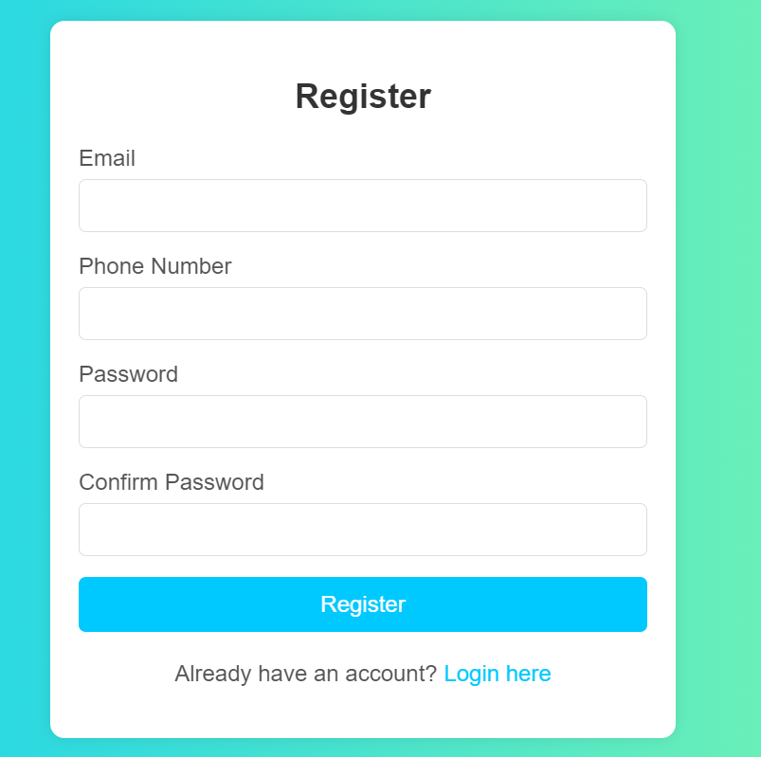

#### 3.5.2.3 Login page

The user logins with username (email) and password.

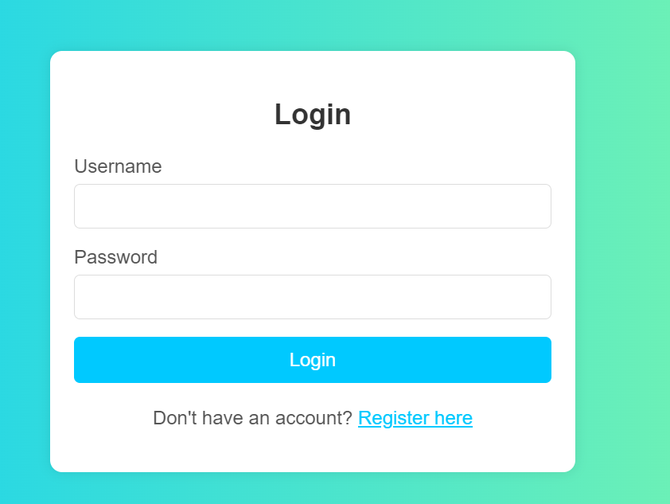

#### 3.5.2.4 Booking Page

At Booking page, the user the type of care to travel with (14 seater or 11 seater), route (from and to) where to seat then proceeds to pay.

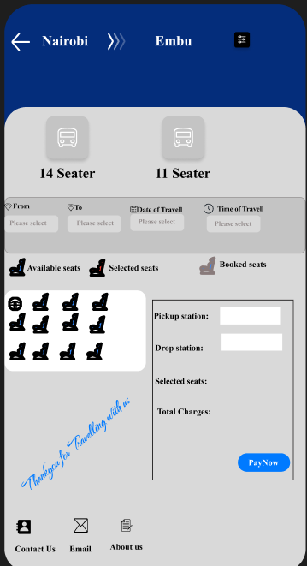

Is at this page that the user either downloads or prints the ticket to be locally stored in their device.